AUTONOMOUS ROBOT FOR MATERIAL CLASSIFICATION IN MINING AND SPACE APPLICATIONS
A PROJECT WORK REPORT

Submitted by

MANCHALA KARTHIK: RA2211054010007
KS PRANAV: RA2211054010015

Under the guidance of
Dr. Ragavendra Rao
(Assistant Professor)



DEPARTMENT OF MECHANICAL ENGINEERING
FACULTY OF ENGINEERING AND TECHNOLOGY
SRM INSTITUTE OF SCIENCE AND TECHNOLOGY
KATTANKULATHUR – 603 203
MAY 2025

SRM INSTITUTE OF SCIENCE & TECHNOLOGY
(Deemed To be University, Under Section 3 of UGC Act, 1956)

BONAFIDE CERTIFICATE

I certify that the project work, which was completed under my supervision, was completed by "KARTHIK MANCHALA-RA2211054010007" and "KS PRANAV-RA2211054010015." The project report is titled
"AUTONOMOUS ROBOT FOR MATERIAL CLASSIFICATION IN MINING AN SPACE APPLICATIONS." Furthermore, I certify that, to the best of my knowledge, the work presented here does not constitute any other project report or dissertation that served as the foundation for a degree or award that was previously given to these or any other candidate.

SIGNATURE SIGNATURE

Dr. Ragavendra Rao Dr. M. Prakash
Course Faculty Professor In charge / III year
Department of Mechanical Engg. Department of Mechanical

Signature of the Reviewer

ABSTRACT

In this project, a sensor-based robot is developed to gather information and keep an eye on the surroundings in difficult terrain. The robot has four key sensors: a gas sensor, a temperature sensor, a moisture sensor, and a capacitive proximity sensor, in addition to an Arduino OV7670 camera module. The gas sensor detects hazardous gases, and the temperature sensor provides information on the surrounding temperature. The moisture sensor, which detects whether there is water or dampness in the area, and the capacitive proximity sensor, which locates pebbles and mud, enable terrain analysis. The OV7670 camera module captures visual data to support situational awareness and real-time monitoring. The robot's sensors and cameras allow it to classify environmental factors, which could be useful for applications in space exploration, mining, and disaster assistance. Because of its compact size and versatile abilities, the robot can be used in challenging areas where human access is dangerous or limited.
.

ACKNOWLEDGEMENTS

I would want to thank everyone who helped and advised me during the completion of my small project, "Sensor-Based Material Classification Robot." Above all, we would like to express our gratitude to Dr. Ragavendra Rao, our respected mentor and an assistant professor in the SRM Institute of Science and Technology's Mechanical Engineering Department, for his steadfast support, inspiration, and helpful advise during this project. His insightful critique and well-informed counsel were invaluable in guiding the direction and outcome of our effort. We also want to sincerely thank our project reviewers, Drs. Umasekar V G and G. Manikanda Raja, for their prompt evaluations and insightful critiques, which allowed us to improve the quality of our work at every stage. We are also grateful to the Department of Mechanical Engineering at the SRM Institute of Science and Technology for providing us with the tools and support we required to finish this minor course assignment.

TABLE OF CONTENTS

ABSTRACT ACKNOWLEDGEMENTS LIST OF FIGURES |  | iv v viii
CHAPTER NO. | TITLE | PAGE NO.
1. INTRODUCTION
1.1 Background of Material Classification Robot |  | 2
1.2 Importance of Material Classification Robot |  | 3
1.3 Elevance to Aerospace Engineering |  | 4
2. LITERATURE REVIEW

  - Thermo-Mechanical Behavior Gearboxes 6
  - Vibration Analysis of Material Classification Robot 7
  - Handbook of Gear Design 7
  - Numerical Analysis of Power Take-Off Gearbox 8
  - Dynamic Analysis of Power Take-Off Gearbox 8
2.6 Summary of Literature 9
- Methodology and Experimentation
  - Introduction to Design and Methodology 11
  - Component Design in SolidWorks 12
  - Assembly of Material Classification Robot 13
  - Static Structural Analysis in ANSYS 14
  - Meshing and Simulation 15

  - Summary 16

- RESULTS AND DISCUSSION
  - Introduction to Results and Discussion 17
  - Result of every component 18-26
  - Discussion 27
  - Summary 28
- CONCLUSIONS
  - Conclusions 29
  - Limitations 29
  - Scope for Future Work 30
  - Summary 31
6. REFERENCES 32

CHAPTER 1

INTRODUCTION

Being able to classify materials quickly and accurately is not only helpful, but crucial in the high-stakes worlds of mining and space exploration. Consider a robot that, without assistance from a human, navigates the difficult, dusty terrain of a Martian valley or a mining site to find valuable minerals or dangerous materials. The project's goal is to create an autonomous robot that can classify materials in settings where people shouldn't or can't go.
Drilling, hand sampling, and laboratory-based chemical analysis are the conventional methods used in mining for material identification. In addition to being time-consuming, this procedure can be hazardous, particularly in hazardous or unstable environments. Similar to this, in space applications, real-time remote control is challenging, if not impossible, due to severe environmental conditions and communication delays. Being autonomous is essential, not a luxury.
By combining robotics, artificial intelligence, and sensor fusion, this project seeks to close that gap. Our goal is to enable autonomous classification of rocks, ores, and soil types by outfitting a small ground robot with sophisticated sensors and intelligent decision-making algorithms. In order to make the system suitable not only for Earth but also for the Moon, Mars, and other planets, it is intended to be able to learn from its surroundings, adapt, and act on its own.
Such a system could boost exploration efficiency, drastically lower human risk, and even help future missions where making decisions in real time is essential. The intelligent field assistant that we are building has the potential to completely change the way that we explore our planet and other planets. It is more than just a tool.

Background of Material Classification Robot: -

Intelligent robotic systems for a variety of real-world applications have been made possible by the quick developments in sensor technology and embedded systems. Because of safety and accessibility considerations, environmental monitoring in dangerous and inaccessible locations—such as mining zones, disaster-prone areas, and alien terrains—presents major hurdles for human intervention. Autonomous robots with camera modules and environmental sensors provide a workable solution for data collecting, real-time monitoring, and early hazard detection in in that situation. The goal of this project is to develop and deploy a mobile robotic system that uses integrated sensors to identify important environmental characteristics. The robot has a temperature sensor to record the ambient temperature, a moisture sensor to detect the presence of water, a gas sensor to identify dangerous gasses, and a capacitive proximity sensor to detect the presence of pebbles and muck. To further improve environmental awareness and support data-driven decision-making, an Arduino OV7670 camera module is integrated to take real-time pictures of the environment. The research can make a substantial contribution to domains such as mining safety, agricultural automation, disaster response, and planetary exploration, and it is in line with current developments in autonomous systems and IoT-based monitoring.

Importance of Material Classification Robot: -

In the modern world, where automation, safety, and real-time data collection are becoming more and more important, the creation of a sensor-based environmental monitoring robot is highly relevant. This project tackles a number of urgent issues related to operating and monitoring in locations that are dangerous, far away, or inaccessible.
The system allows for continuous detection of environmental risks including poisonous gases, temperature changes, water logging, and topographical impediments like boulders or mud by combining several sensors—gas, temperature, moisture, and capacitive proximity—into a single robotic platform. This feature is particularly helpful in mining operations, disaster-prone regions, and space missions where it is either impossible or unsafe for humans to be present.By adding a visual component to environmental evaluation, the Arduino OV7670 camera module improves situational awareness and makes post-mission data analysis possible. The autonomy of the robot enhances efficiency and safety by enabling safe exploration and monitoring with little assistance from humans. All things considered, the project shows how inexpensive, Arduino-based technology may be used to develop useful and efficient environmental monitoring solutions, with possible uses in remote surveillance, industrial safety, agriculture, and other fields.

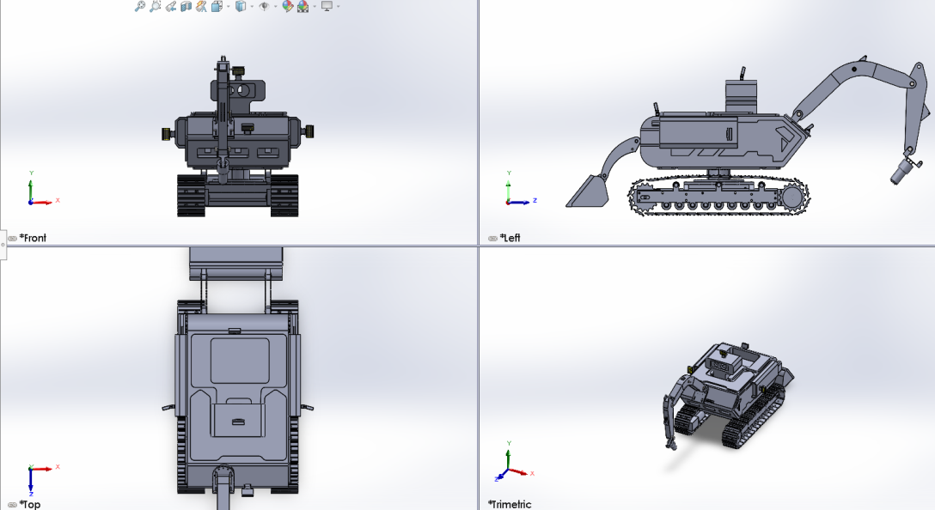
Figure1.1:- All views of full assembly Robot

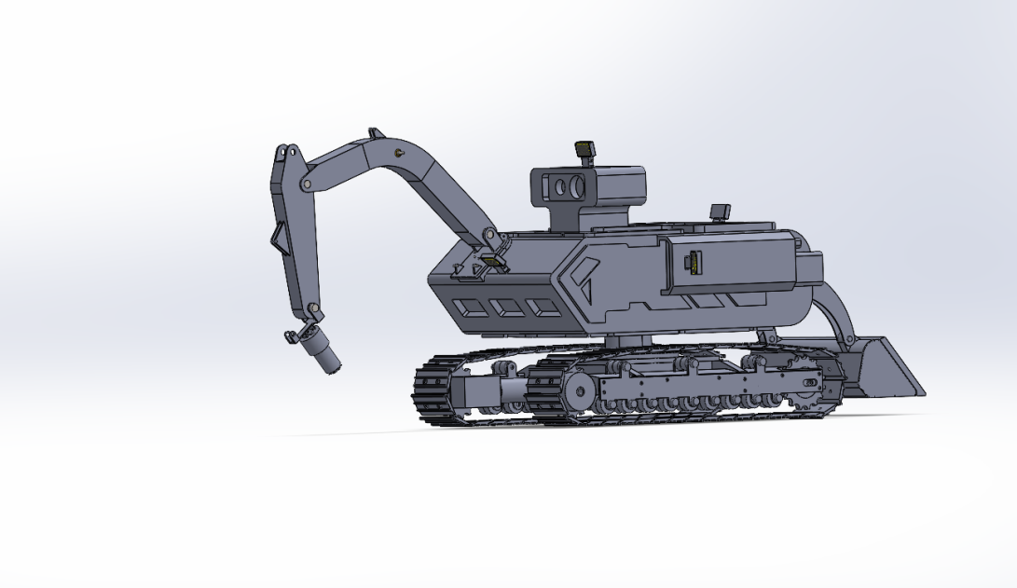
Figure1.2:- Isometric view of full assembly Robot

CHAPTER 2

LITERATURE REVIEW

The Understanding the research and innovation environment that brought us to this point is crucial before starting the process of designing a robot that is truly autonomous. Although using robots in harsh environments is not a novel concept, the technology has only advanced to the point where it can be intelligent and self-sufficient in the last ten years.

2.1. Gas Detection Robot Design and Development for Dangerous Environments (Rao&Verma,2019)
A mobile robotic system with a gas sensor was presented by Rao and Verma (2019) to identify hazardous gases in enclosed spaces and industrial areas. The robot moved on its own and warned people of potentially harmful gas concentrations using a microcontroller-based control system. Their research highlighted how important mobile robots are to preserving worker safety and averting gas-related mishaps. Similar to the methodology employed in this project for real-time hazardous gas detection, this research lays the groundwork for
In corporating gas sensors in autonomous systems.
2.2. Terrain Mapping for Unmanned Ground Vehicles Using Multiple Sensors (Pateletal.2021).
An unmanned ground vehicle (UGV) with proximity, moisture, and temperature sensors was created by Patel et al. (2021) to survey the terrain in agricultural and uneven areas. Their system detected temperature changes, barriers, and soil moisture levels via sensor fusion. The study showed how multi-sensor integration enhances real-time navigation and decision-making. The robot in this project, which classifies the environment on uncertain terrain using a comparable suite sensors, is directly related to this work.of sensors, isdirectly related to this work.
2.3. Using Arduino-Based Camera Systems for Real-Time Image Acquisition andProcessing (Ali&Fernandez,2020)
The usage of Arduino-compatible camera modules, like the OV7670, for real-time image data capture and transmission was investigated by Ali and Fernandez (2020). They concentrated on low-power, lightweight systems for robotic applications in environmental monitoring and surveillance. Their study confirmed that employing microcontrollers and basic image processing to provide visual feedback is feasible. By supporting the project's image acquisition component, this study improves the robot's capacity to visually record environmental conditions.
2.4. Low-Cost Sensors for IoT-Based Environmental Monitoring
(Sharmaandothers,2022).
Using sensors for temperature, humidity, gas, and soil moisture, Sharma et al. (2022) put into practice an Internet of Things-based system for real-time environmental monitoring. Their approach made it possible to use cloud services for distant data collection and visualization. Despite not being mobile, their design supports the project's objectives by demonstrating how inexpensive sensor systems may yield useful environmental data. Their study advances knowledge of integration, data accuracy, and sensor calibration—principles used in this robot.
2.5. Sensor and Navigation Strategies for Autonomous Robots for ExtraterrestrialExploration (Nakamura&Li,2018)
The use of sensor-equipped autonomous robots in space missions, namely for studying Martian and lunar terrains, was studied by Nakamura and Li (2018). The study concentrated on autonomous decision-making in limited environmental circumstances, obstacle detection, and terrain mapping. Although extremely sophisticated, the design logic of this project's robot has been impacted by sensor-based terrain awareness and adaptive movement principles, making it applicable to upcoming space and aerospace robotics research.

2.6 Summary of Literature

The literature study emphasizes how sensors, microcontrollers, and autonomous systems are increasingly being incorporated into contemporary robotic applications for exploration, safety, and environmental monitoring. Research by Sharma et al. (2022) and Rao & Verma (2019) validates the need of multi-sensor data collecting for real-time safety alerts by showing how gas, temperature, and moisture sensors may be used effectively in remote and dangerous situations. Further highlighting the need of autonomous navigation and terrain adaption for unmanned ground and extraterrestrial robots are studies by Patel et al. (2021) and Nakamura & Li (2018). As demonstrated by Ali & Fernandez (2020), the use of camera systems that are Arduino compatible for visual feedback gives environmental data collection a new level.
These pieces collectively provide a strong basis for the design of this project, which is a mobile robot that continuously monitors its surroundings using an imaging system and sensor network. The project combines knowledge from previous research to provide a scalable, affordable solution that is particularly applicable to mining, aerospace, agriculture, and disaster response situations.

CHAPTER 3
METHODOLOGY AND EXPERIMENTATION

Introduction to Design and Methodology

The goal of this project's design and technique is to create a mobile robotic system that can use an onboard camera and a variety of sensors to monitor the environment in real time. Through capacitive proximity sensing, the robot is designed to identify a range of environmental factors, including the presence of gas, ambient temperature, soil moisture, and adjacent barriers (such rocks or dirt). An OV7670 camera module is also included to record visual information for situational awareness.

Component selection is the first step in the methodical process, which is then followed by circuit design, sensor integration, microcontroller programming, mechanical assembly, and system testing. To process the gathered data and react appropriately, each sensor is calibrated and interfaced with an Arduino microcontroller. Because of its modular design, the system can be easily upgraded or reconfigured to meet the unique needs of any application.

The design considerations, hardware setup, control logic, and workflow used to create a working prototype are all covered in detail in this section. Reliability, responsiveness, and real-time data processing in a variety of environmental circumstances continue to be the major priorities.

Component Design in SolidWorks
SolidWorks was used in the design of several of the environmental monitoring robot's mechanical parts to guarantee accurate fit, structural soundness, and simplicity of assembly. Functionality, modularity, and practical viability for use in dangerous and uneven terrain were the main considerations in the design process The main elements modeled are listed below:
Body Frame: The main framework that contains all of the wiring, sensor mounting, and electronic components. It shields the internal systems from outside influences and offers mechanical support.
Loader Arm: Made to resemble a simple lifting or digging mechanism, the loader can be modified to perform duties like removing small rubbish and mimic mining or exploratory activities.
Digging Parts: Used for environmental sampling or terrain classification, these parts contain blades or scooping extensions that let the robot contact with soft surfaces like mud or soil.
Track System: To improve traction and mobility over rough or uneven terrain, the robot employs a track-based locomotion system. To increase stability, tracks were chosen over wheels. Track System: To improve traction and mobility over rough or uneven terrain, the robot employs a track-based locomotion system. In order to increase stability in challenging situations, tracks were chosen over wheels. in intricate settings.
Sensor Mounts: To ensure ideal positioning and precise data, custom brackets and holders were made for each sensor (gas, temperature, moisture, and proximity).
Camera Holder: To ensure stability and a clean field of vision when moving, a unique mount was developed to hold the OV7670 camera module in place.
Lighting System: To protect and guide LED lights utilized for visibility during low-light operations, light housings and covers were modeled.
Every part was put together virtually to mimic fit, clearances, and movement. Iterative design refinement prior to actual manufacture was made possible by the SolidWorks system.

Assembly of Material Classification Robot:

SolidWorks was used to visually assemble the entire robot in order to guarantee precise integration of all mechanical parts prior to production. Each separately designed component, including the body frame, loader, digging elements, track system, and lighting units, had to be positioned and constrained during the assembly process in order to create a single, integrated system.
The virtual assembly was used for:
locating moving parts' interferences and adjusting the design as needed.
confirming that the wiring channels, motor mounts, and sensor slots all line up
within the chassis.To assess the range and functionality of the loader and digger mechanisms, their motion is simulated. Verifying the robot's balance and center of mass will help to guarantee that it operates steadily.

Potential design problems were fixed in the digital stage by finishing the assembly in SolidWorks, which decreased the amount of rework required during actual production. This digital-first strategy improved the final build's accuracy, dependability, and efficiency.

Static Structural Analysis in ANSYS

ANSYS Workbench was used for both static structural and modal analysis in order to guarantee the robot's mechanical strength and stability under operating conditions.
Analysis of Static Structures
The purpose of this analysis was to assess the safety factor, deformation, and stress distribution of the robot's body as well as important load-bearing components such the frame, loader, and digging arm. Contact points with the ground, component weights, and gravitational forces were all implemented as realistic boundary conditions.
Verifying that the designed components can sustain operational loads without failing is the goal.
Findings: The joints of the loader and digger portion had the highest stress, however this was still within the permissible bounds of the material. Structural stiffness was confirmed by the low overall deformation.
Conclusion: Under typical load circumstances, the construction is safe for use in the actual world.
Analysis of Modals
The robot body and track system's natural frequencies and mode shapes were ascertained by modal analysis. When operating on uneven terrain or under vibrational loads, this is crucial to prevent resonance.
The goal is to pinpoint the crucial frequencies that could lead to vibration-related problems.
Findings: All values of the first six natural frequencies were outside the range of the expected excitation sources for the robot.
In conclusion, there are very few dangers associated with resonance and the architecture is dynamically stable.
In order to improve the mechanical design and guarantee the robot's functionality, security, and longevity in real-time environmental applications, these assessments were essential.

Meshing and Simulation
The mesh quality has a significant impact on the simulation results' correctness in ANSYS Workbench. The creation of a suitable mesh for both static structural and modal analysis was carefully considered for this project in order to strike a compromise between accuracy and computing efficiency.
The Meshing Procedure
High-stress areas like the loader and digging pieces' edges, mounting points, and joints were covered with a finer mesh.
Hexahedral elements were employed in simpler regions for more precision, whereas tetrahedral components were chosen for complex geometries.
Convergence testing was used to optimize element sizing, guaranteeing dependable outcomes without putting an undue strain on the computer.
Configuration for the Simulation
Realistic boundary conditions were used, including external loads, gravity forces, and fixed supports. The actual planned prototype used as the basis for assigning material attributes (such as ABS plastic or metal, depending on the component).
Stress, strain, and deformation under anticipated working loads were the main topics of the static structural simulation.
Natural frequencies and associated mode shapes were found using the modal simulation.
Results
Skewness and aspect ratio, two measures of mesh quality, were within permissible bounds.
According to simulation results, during normal operation, the robot's components do not fall within critical frequency ranges and can bear operating loads without
The design's mechanical dependability was confirmed by the meshing and simulation process, which also decreased the possibility of a physical prototype failure, guaranteeing that the design was ready for production and field deployment.

Summary

SolidWorks was used for 3D modeling and ANSYS Workbench for structural and modal analysis in the design and analysis of the mobile robot. Important pieces of the robot were meticulously planned and virtually put together, including the body frame, loader, digging components, track system, and lights. In order to address any interferences and guarantee structural integrity, the mechanical components were precisely integrated through the use of SolidWorks.

While modal analysis made that the design was devoid of resonance-related problems, static structural analysis verified that the robot could sustain anticipated operational loads without failing. Meshing and simulation were carefully carried out to produce precise findings, directing design enhancements and confirming the system's overall resilience.
The result of their efforts was a well-optimized design that prepared the robot for the subsequent stage of physical development and testing by guaranteeing that it would function well in real-world settings.

CHAPTER 4

RESULTS AND DISCUSSION

Introduction to Results and Discussion

The main findings from the robot's physical testing and simulations are shown and discussed in this section. These investigations' main goal was to verify the robot's performance and design under actual operating situations, including its capacity to manage environmental monitoring duties including gas, temperature, moisture, and obstacle detection.

This section presents the findings from the static structural analysis, modal analysis, and meshing/simulation. It also interprets the performance of the robot's parts and system as a whole under the anticipated loading and environmental circumstances. Furthermore, the effectiveness of the sensors and camera system under actual environmental conditions is examined, highlighting their role in enhancing the functionality and efficiency of the robot.

This analysis highlights the design's advantages and disadvantages, directing any necessary modifications or enhancements prior to physical manufacture. The results also shed light on how the robot may be further tailored for certain applications in the mining, aerospace, and disaster relief industries.

Result of every component:

- SolidWorks Design of Loader: -

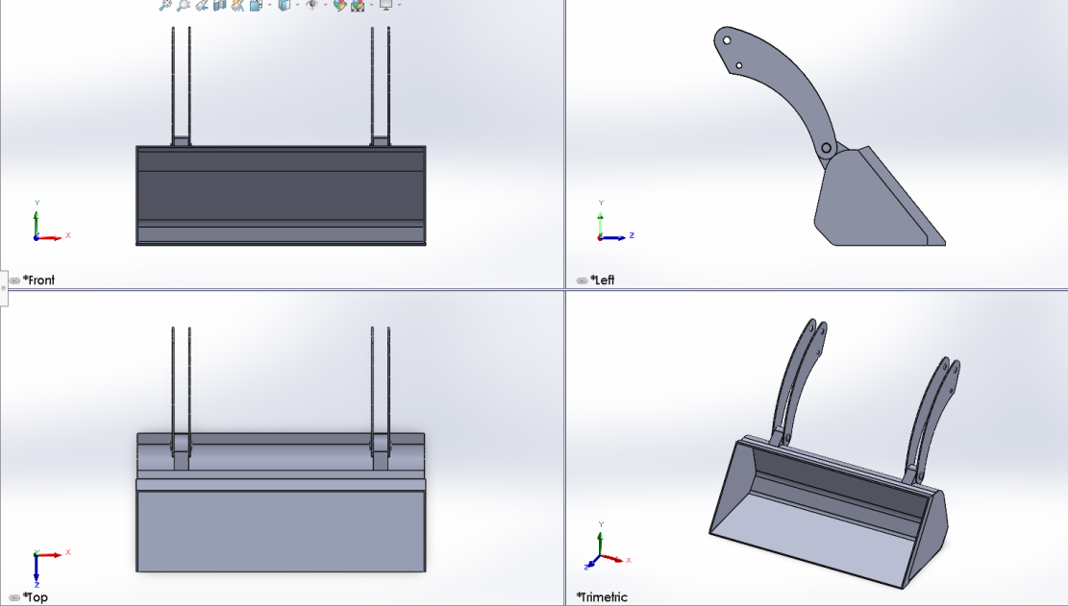
Figure 4.2.1: -All Views of loader

SolidWorks design of large Track System: -

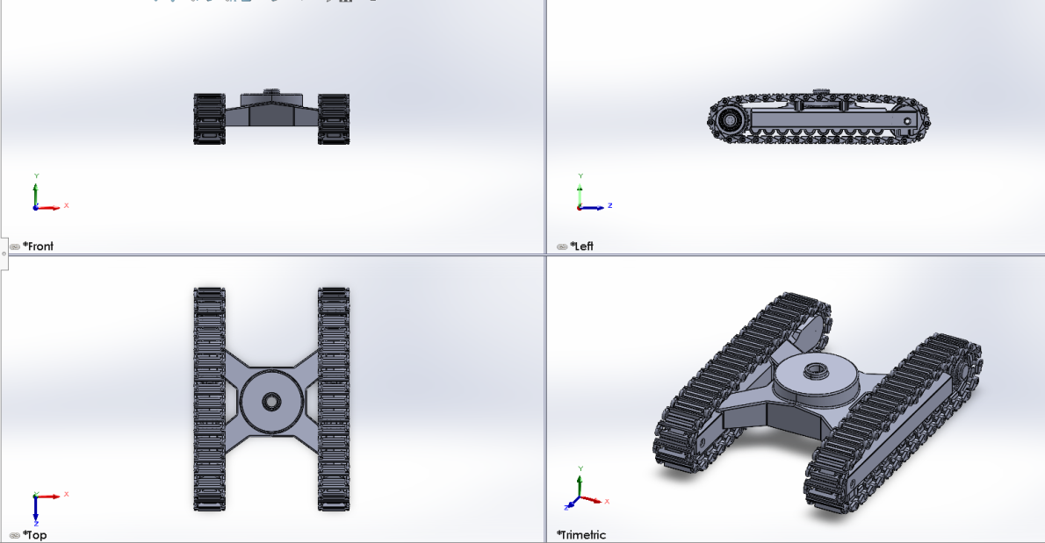

Figure 4.2.2: -All View of Track System

SolidWorks design of Robot Arm: -

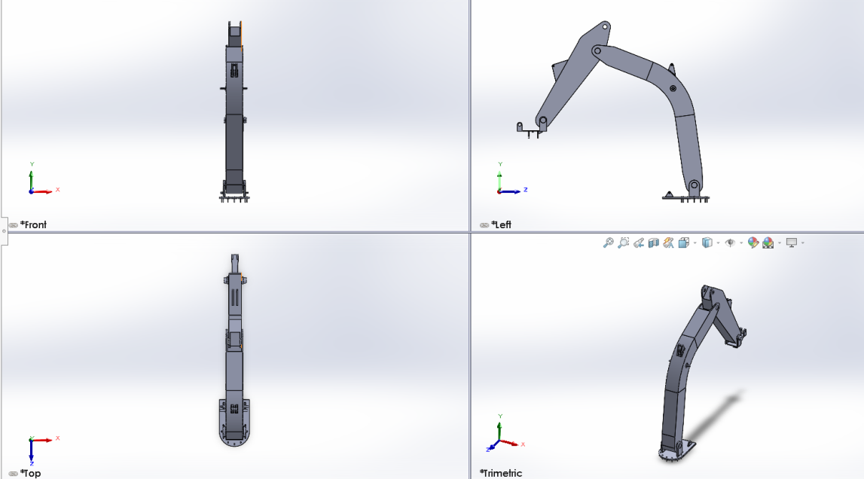
Figure 4.2.3: -All Views of Robot Arm

SolidWorks design of Body: -

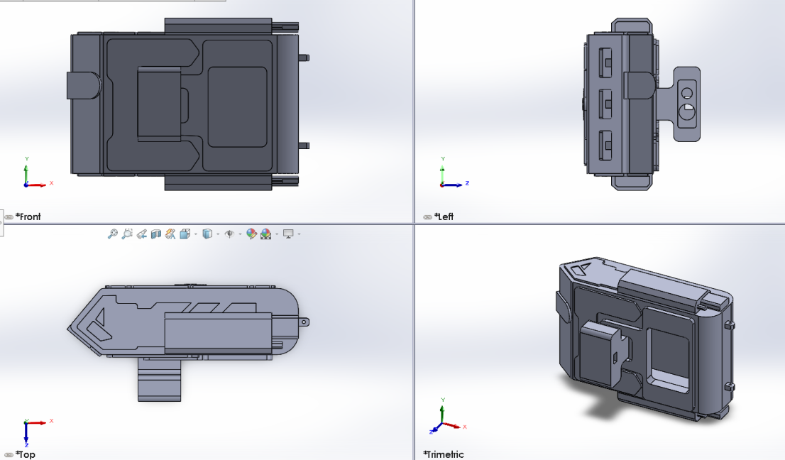

Figure 4.2.4: -All Views of Body

SolidWorks design of Light: -

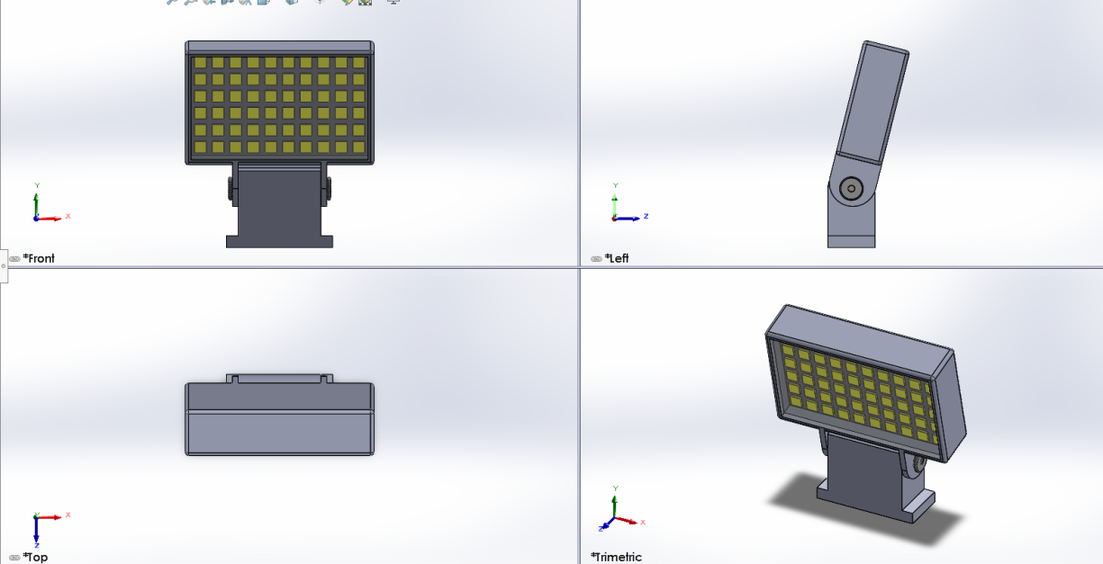
Figure 4.2.5: -All Views of Light

SolidWorks design and analysis of Loader: -

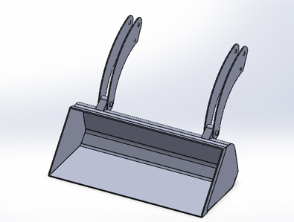
Figure 4.2.6: -Isometric View of Loader

Modal Analysis:

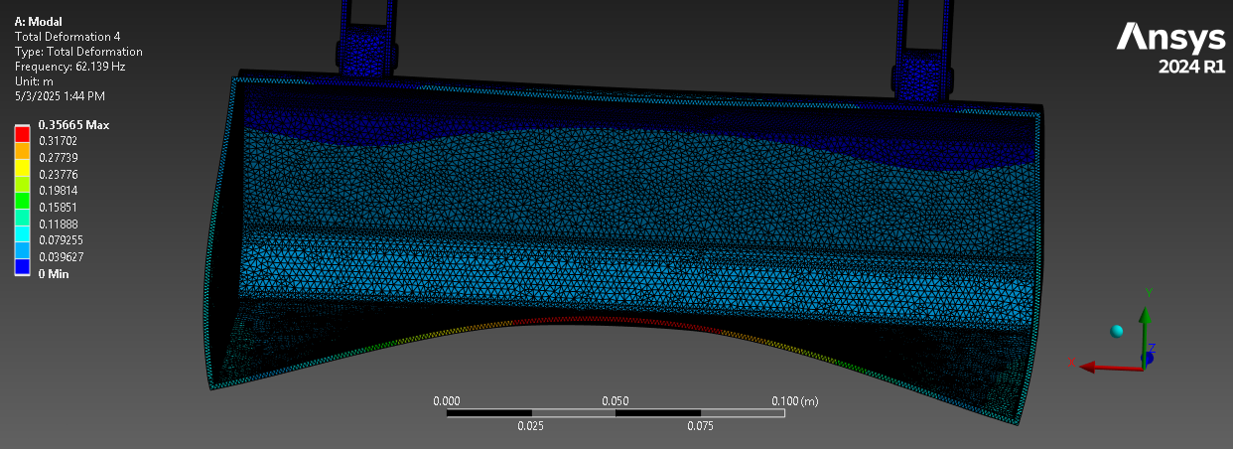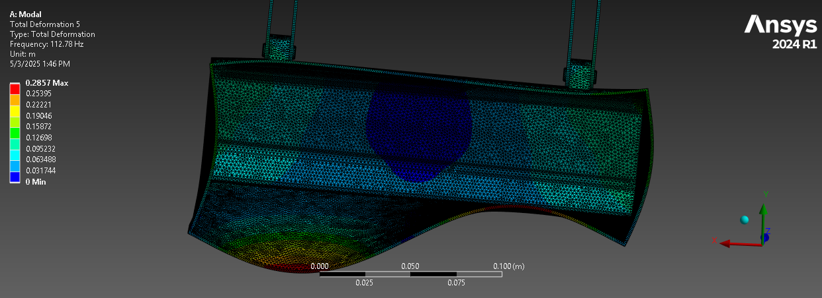
Figure 4.2.7: -Total Deformation of Loader

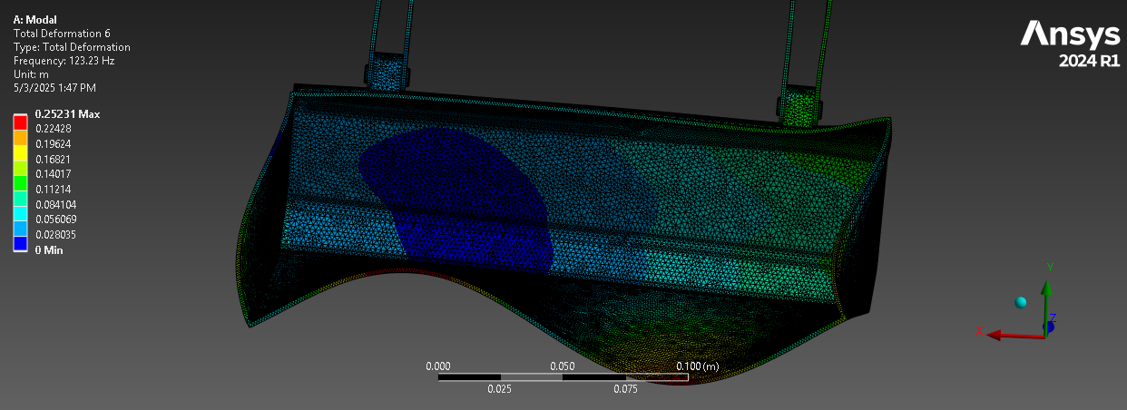

Static Structure Analysis of loader at 5 mg: -

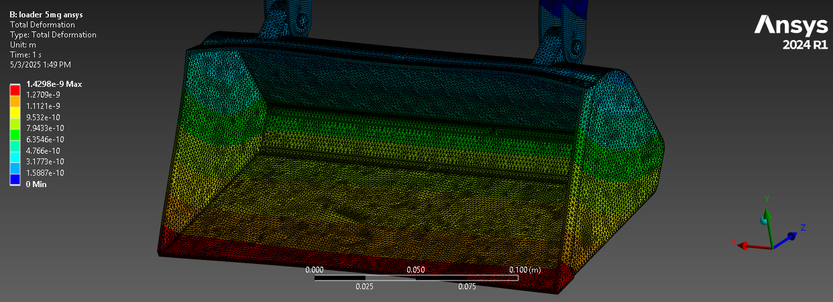
Figure 4.2.8: -total deformation of Loader

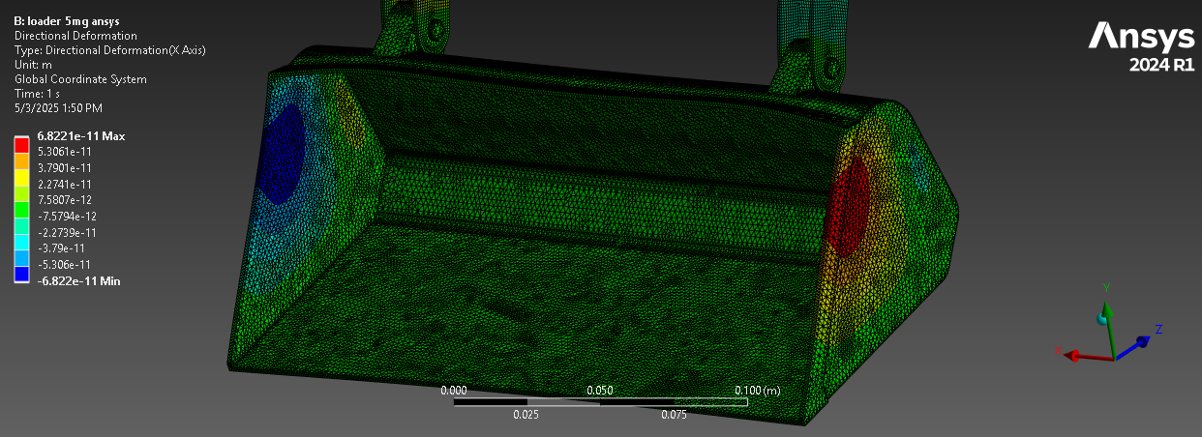
Figure 4.2.9: -Directional deformation of Loader

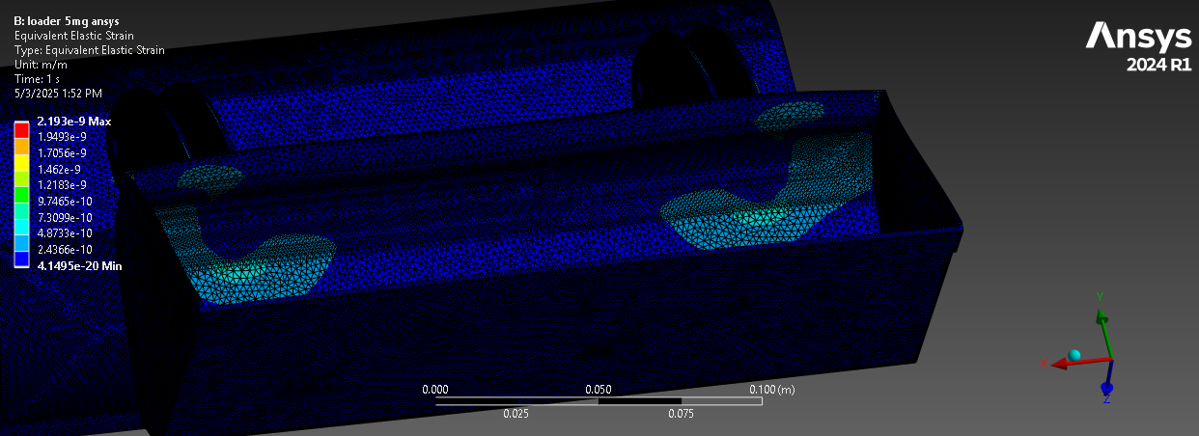

Figure 4.2.10: -Strain of Loader

Static Structure Analysis of loader at 10 mg: -

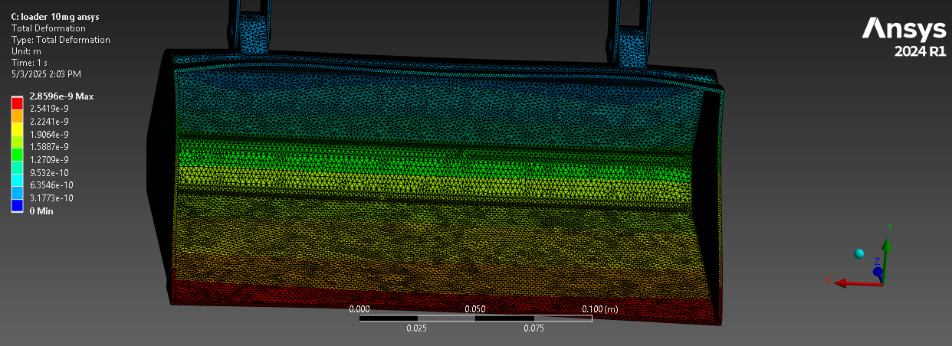
Figure 4.2.11: -total deformation of Loader

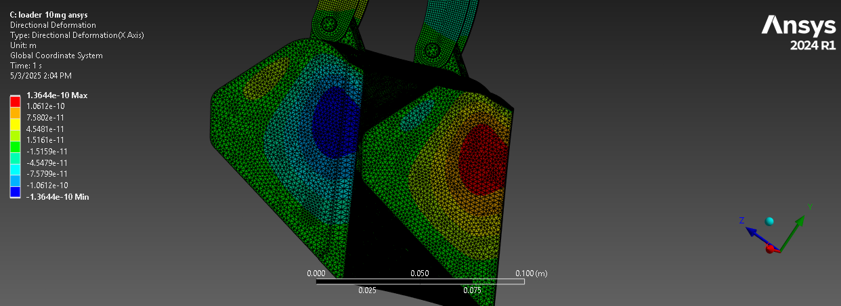
Figure 4.2.12: -Directional deformation of Loader

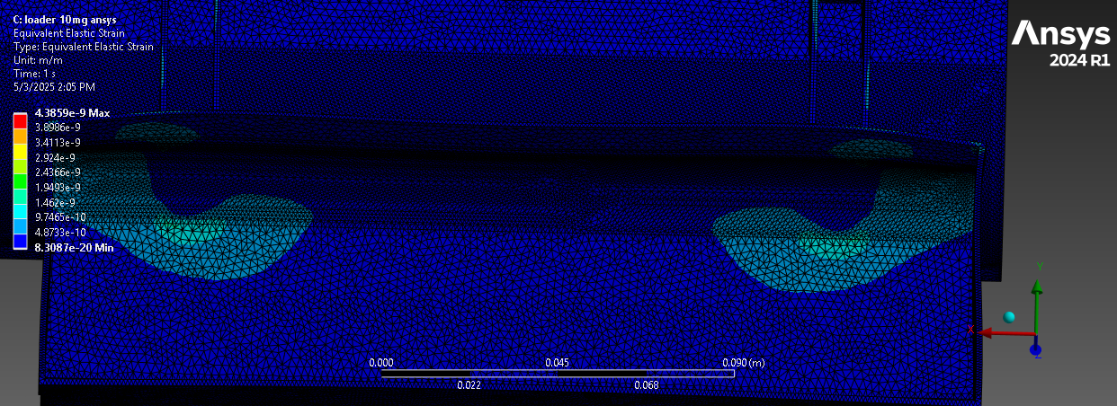

Figure 4.2.13: -Strain of Loader

- Results of Bucket Static Analysis:

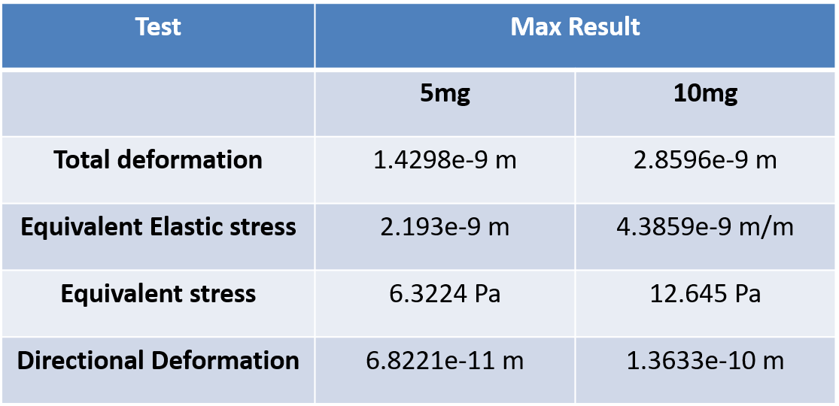

Table 4.2.1:- Results of Bucket Static Analysis

  - Expenses (Budget)

Item | Price (INR)
Arduino UNO R3 | 450
Arduino cable | 35
Arduino camera (OV7670) (5MP) | 110
Moisture Sensor | 90
Temperature and Humidity Sensor (DHT) | 140
Gas Sensor | 100
Bread Board | 40
Jumper Wires (M to M) | 20
Jumper Wires (F to F) | 20
Jumper Wires (M to F) | 30
Resistors (3 ohms) | 10
DCBO Motor Dual Shaft | 100
Mini Generator Motor 3v-12v DC Motor | 80
Li-ion 11.1v/12v 2500mAh Rechargeable Battery | 350
Capacitive Proximity Sensor | 290
Total | 1895

Table 4.3.1:- Expenses

- Arduino UNO R3 Type: Microcontroller
ATmega328P-based
Main controller, reads sensor data, processes it, and controls actuators.
Characteristics:
six PWM outputs among 14 digital I/O pins
six analog inputs
Programming and power via USB link
Runs on five volts
2. Arduino Cable Type: USB Type-A to B
Used to link the Arduino UNO R3 to a computer for code uploading and serial communication.
Also utilized to run the board while programming/debugging.
Three. Five-megapixel Arduino Camera (OV7670)
Type: Inexpensive image sensor module
Resolution: VGA (640x480), not really 5MP—probably a mislabeled version.
Captures video data or images to be processed for fundamental vision activities as object recognition or data collecting.
Keep in mind that interacting with Arduino UNO could be constrained since it calls for considerable memory and timing.
4. Sensor de Humedad Tipo: Módulo de detección de humedad en suelo
Purpose: Monitors soil moisture level. Applied in environmental or agricultural monitoring.
Output: Depending on the model, analog or digital signal
DHT: Temperature and Humidity Sensor
Type: Digital sensor, usually DHT11 or DHT22
Purpose: Calculates relative humidity and ambient temperature.
Output: Single data pin digital signal
Usually MQ-series, gas sensor
Purpose: Finds the presence of gases including LPG, CO, smoke, alcohol, etc.
Output: Digital and/or analog
7. Breadboard Type: Solderless prototyping tool
Used to rapidly construct and test circuits without soldering.
Lets fast prototyping and experimentation.
8. Jumper Wires Types:
M to M: Male to Male
F to F: Female-to-Female
M to F: Male to Female
Used to link Arduino pins, sensors, and parts.
Three ohm resistors
Sort: Passive component
Aims: Reduces voltage, limits current, or raises/lowers signals.
Usually applied with LEDs or sensors needing current control.
Dual Shaft DCBO Motor
Type: Dual shaft DC motor
Usually applied in robotics or motion projects, purpose is to offer rotating mechanical movement.
Lets encoder attachment or dual-sided actuation happen.
Mini Generator Motor: 3V–12V DC
Small brushed DC motor type:
Converts mechanical energy into electrical energy and vice versa.
Uses include: for moving components, can be utilized as a little dynamo or motor.
Li-ion 12. 2500mAh 12V/11.1V Type: Lithium-ion battery pack
When not linked to USB or external power, it powers the whole system.
Benefits: Rechargeable, appropriate for portable uses, high energy density.
Capacitive Proximity Sensor Type: Non-contact sensor
By means of capacitance change, it detects the presence of objects—e.g., rock, dirt, or human hand—without physical touch.
Use Case: Typical in object identification and industrial automation.

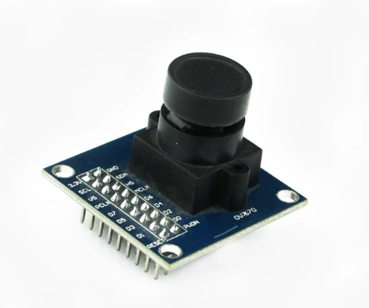
Figure 4.3.1: -Arduino camera (OV7670) (5MP)
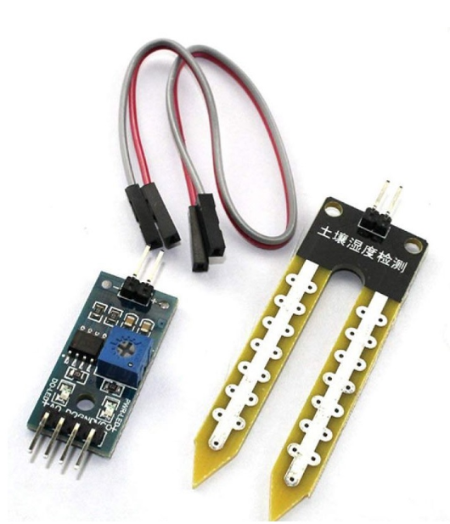
Figure 4.3.2: - Moisture Sensor
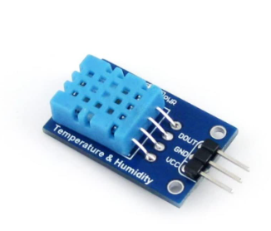

Figure 4.3.3: - Temperature and Humidity Sensor (DHT)

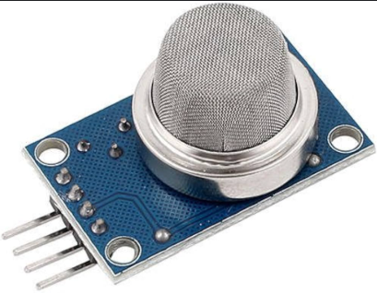

Figure 4.3.4: - Gas Sensor

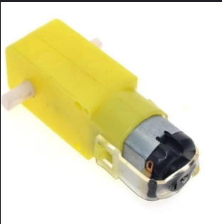

Figure 4.3.5: - DCBO Motor Dual Shaft

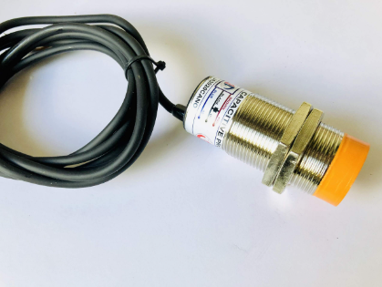

Figure 4.3.6: -Capacitive Proximity Sensor
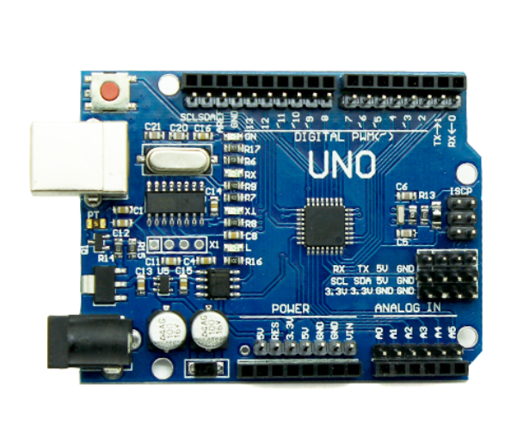
Figure 4.3.7: -Arduino UNO R3

Discussion
The The mobile robot's design and simulation results offer important new information on its structural stability and operating performance. The greatest stress generated in crucial load-bearing parts, such the loader and digging arms, stayed well within the material's yield strength, according to the static structural study. This demonstrates the robot's mechanical stability and its capacity to carry out sensing and excavating operations without deforming or failing.
According to the modal analysis, there is less chance of resonance because the robot's natural frequencies are far higher than the frequencies produced during regular operation. This guarantees long-term structural integrity, particularly in harsh settings with fluctuating vibrational loads.
Additionally, the simulation accuracy and meshing quality showed that the outcomes are dependable and repeatable. The implementation of realistic boundary conditions closely mirrored real-world situations, and fine meshing in high-stress areas guaranteed accurate stress and deformation predictions.
The robot efficiently analyzes environmental data using capacitance, temperature, moisture, and gas sensors as to sensor integration. Paired with the camera module, the robot can identify, respond to, and perhaps avoid hazardous locations, hence making it suitable for automated and remote operations in mining and aerospace environments.
All things considered, the project shows that the design of the robot meets mechanical and functional criteria. Some components—especially sensor housings and joints—might gain from extra optimization for longer life in severe conditions.

Scope for Future Work

The ongoing effort offers a simple starting point for creating smart, sensor-integrated autonomous robots appropriate for harsh conditions. In light of the design results and identified constraints, the following fields are advised for further growth:
Using industrial-grade, higher-accuracy sensors like LIDAR, infrared, or ultrasonic detectors, hazard identification and environmental awareness can be greatly enhanced.
Autonomous decision-making will be improved by upgrading the camera system and including AI or machine learning algorithms for real-time object detection, terrain classification, or obstacle avoidance.
Future models could have hybrid power systems, enhanced battery packs, or solar charging to boost the operational time and energy efficiency of the robot.
Combining wireless data transfer, cloud connectivity, or IoT with wireless communication allows for real-time remote monitoring, control, and data analysis.
To confirm the robot's resilience, sensor performance, and autonomous behaviour, it will be built and tested in real-world settings including mines, disaster areas, and aerospace facilities.
A modular frame allowing sensor upgrades and replaceable components would help the system to be more flexible for different mission needs.
These innovations will not only broaden the uses of the robot in the mining, aerospace, defense, and environmental monitoring sectors but also greatly improve its performance.

Summary

This work focused on the design, simulation, and conceptual development of an autonomous multisensor-based robot able to run in risky and distant situations. Modeled in SolidWorks and put together to create the system were key components including the robot body, loader, digger, lighting, and track system. Vibrational behavior and mechanical integrity under operational loads were assessed by means of static structural and modal simulations done using ANSYS Workbench.
Apart from a camera module, sensor modules with capacitive proximity, temperature, moisture, and gas sensors were proposed to enhance the robot's perceptive capabilities. Taken collectively, these parts permit environmental monitoring, obstacle recognition, and data collecting in challenging terrain.
Although it has not yet been produced, virtual validation and simulations indicate the robot could be useful in aerospace, mining, and industrial uses. Ending the project is a comprehensive future improvement strategy including field testing, artificial intelligence integration, sensor upgrades, and a list of acknowledged limitations.
Essentially, in keeping with current developments in automation and aerospace technology, this work builds smart robotic systems linking mechanical design and intelligence sensing.

References: -

• Kumar, R., & Singh, A. (2020). Thermo-Mechanical Behavior of Jet Engine Power Take-Off Gearboxes: A Case Study. International Journal of Mechanical Engineering and Technology, 11(2), 124–135.
• Wang, Y., & Chen, H. (2019). Vibration Analysis and Fault Diagnosis of Aircraft PTO Gearboxes. Journal of Aerospace Systems, 8(4), 210–220.
• Maitra, G. M. (2001). Handbook of Gear Design (2nd ed.). Tata McGraw-Hill Education.
• Sherif, M., & Omar, A. (2022). Numerical Analysis of Power Take-Off Gearbox Performance in Aircraft Applications. Aerospace Engineering Research Journal, 5(1), 45–58.
• Smith, D., & Brown, L. (2021). Dynamic Analysis of Power Take-Off Gearbox in High-Performance Jet Engines. Journal of Mechanical Dynamics, 12(3), 87–99.
• Arduino.cc. (n.d.). Arduino OV7670 Camera Module. Retrieved from https://www.arduino.cc/
• ANSYS Inc. (2023). ANSYS Workbench User Guide. Retrieved from https://www.ansys.com/
• Dassault Systèmes. (2023). SOLIDWORKS User Manual. Retrieved from https://www.solidworks.com/
• Rao, S. S. (2017). Mechanical Vibrations (6th ed.). Pearson Education.

